**Abstract**

RFID stands for Radio-Frequency Identification and it uses electromagnetic fields to spontaneously and automatically identify and record tags that have been attached to various objects in the environment. A RFID system usually consists of a RFID scanner/reader and RFID tags. A RFID tag is made up of a very small radio transponder, a radio receiver and a transmitter.

The main basis for this paper is to explore the future aspects of RFID systems by using backscattering to increase the range of a RFID tag. The main aim of the authors is to theorize and create a Tunneling RFID tag which is capable of transferring data at a much larger range than a normal RFID tag.

1. **Introduction**

RFID is an acronym for radio-frequency identification and refers to a technology whereby digital data encoded in RFID tags or smart labels are captured by a reader via radio waves. RFID is similar to barcoding in that data from a tag or label are captured by a device that stores the data in a database. RFID, however, has several advantages over systems that use barcode asset tracking software. The most notable is that RFID tag data can be read outside the line-of-sight, whereas barcodes must be aligned with an optical scanner.

Backscattering (or backscatter) is the reflection of waves, particles, or signals back to the direction they came from. Backscattering is defined also as the phenomenon that occurs when radiation or particles are scattered at angles to the original direction of motion of greater than 90°. It is a diffuse reflection due to scattering, as opposed to specular reflection like a mirror. The term is used in several fields of physics, as well as in photography, telecommunication, computer network security, security imaging systems, and e-mail.

The Internet of things (IoT) is a system of interrelated computing devices, mechanical and digital machines are provided with unique identifiers and the ability to transfer data over a network without requiring human-to-human or human-to-computer interaction.

By the end of 2020, it is speculated that 210 billion of connected Internet-of-Things devices will be connected that will utilize wireless technology to be able to communicate with each other and to human users as well. One of the main concerns of the IoT devices connected across the world is energy consumption and the demand for constant battery replacement which are the major drawbacks of using IoT devices. Backscattering communication through RFID nodes is a promising solution to solve the IoT energy burden of the future, but this technology is still limited in range and is not currently competitive with the wider coverage areas of BLE, Wi-Fi, and cellular networks. Several steps have been undertaken among the research community to overcome backscattering communication limits.

Researchers have highlighted the need of an increased UHF bandwidth for accurate positioning and ranging with RFIDs, but only a few experimental results demonstrating the long-range potential of RFID transponders have been reported thus far.

Presently, a BLE module used in IoT applications requires 10.8 mW [4] to communicate; if operating one third of the time, a coin cell battery-assisted module will consume more than 50 batteries per year. If those batteries will need to be replaced upon discharge, they will contribute to a volume exceeding 10,000,000 m3 in electronic waste, filling up a vast amount of space.

1. **Literature Survey**

[1] Shao, Shuai, et al. “Broadband Textile-Based Passive UHF RFID Tag Antenna for Elastic Material.” *IEEE Antennas and Wireless Propagation Letters*, vol. 14, 2015.

RFID uses radio frequency waves to interact with the RFID tag. The RFID tag gets activated only when the RFID scanner is nearby around 10 to 20cm. The commercially available RFID tag are not very flexible and this effects the durability. This paper talks about how more flexible textile-based RFID tag can be implemented. The commercially available RFID tag antennas work in UHF (Ultra High Frequency) spectrum range. This spectrum range is defined from 952 to 954 MHz. The widely used high-powered systems using a passive tag can use an antenna whose power is between 10 mW to 1 W and an antenna gain defined by the power transmitted by the antenna in a particular direction can be of 6 dBi.

By using a flexible and textile based RFID tag antenna it was demonstrated that the antenna achieves a bandwidth of 263MHz in free space and it also maintains its tuned behavior when the tag is placed in dielectric medium. The performance of the designed tag was also observed and it was concluded that the tag does not degrade under mechanical deformation up to 10%, which good evidence that the tag can handle hostile environments.

[2] Scherhaufl, Martin, et al. “UHF RFID Localization Based on Evaluation of Backscattered Tag Signals.” *IEEE Transactions on Instrumentation and Measurement*, vol. 64, no. 11, 2015.

In this paper the localization of the RFID is based on evaluation of backscattered tag signals. By combining phase and amplitude evaluation the accuracy and the robustness of the estimation of tag position if improved compared to the approach of using either one of them. The passive RFID transponder which is used to estimate the position of the tag communicates its information by means of backscatter modulation, where the reflection coefficient of the tag antenna is switched between two stages in accordance with the data being sent. Hence the localization can achieve based on PoA and amplitude as these parameters rely on the position of the RFID transponder. Furthermore, the algorithm used here does not rely on reference transponders.

[3] Scherhaufl, Martin, et al. “Robust Localization of Passive UHF RFID Tag Arrays Based on Phase-Difference-of-Arrival Evaluation.” *2015 IEEE Topical Conference on Wireless Sensors and Sensor Networks (WiSNet)*, 2015.

The RFID localization system used here rely on phase evaluation of the tag response signal. This evaluation is represented using the term phase of evaluation (PoA). A multiple input multiple output system is designed which consists of each frontend is configured to work as transmitter and the remaining frontend is configured to work as receiver. The measurements were carried out in an indoor office. A 2D representation of the position measurement was demonstrated for the passive RFID tags based on PoA evaluation of the signals. The ambiguity in the phase measurement is handled by arranging tags in a uniform linear array to simultaneously estimate its position.

1. **Rationale**

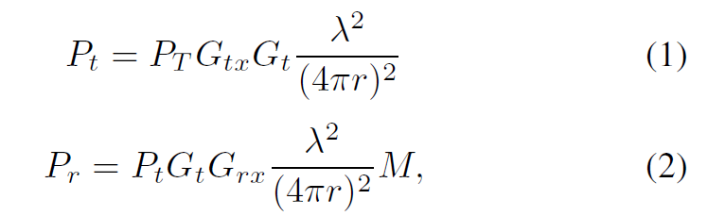To improve the range r of backscattering communications characterized by the following link budget equations:

Both the tag transponder and the reader sensitivities can be improved so that the former can activate its circuitry with lower levels of impinging power Pt while the latter can detect lower levels of received backscattered powers Pr; moreover, the gains of both the transponder antenna Gt and the reader receiving antenna Grx can be increased; additionally the tag transponder loads can be chosen so that its modulation factor, M = ¼ [Ӷ1 - Ӷ2]2, can achieve values greater than 1. Limits are imposed on both the transmitting power PT and the transmitting antenna gain Gtx of the reader whose maximum EIRP must be 36 dBm.

Tunnel diodes can be used for different applications [5]: besides behaving like a Schottky diode when large biases are applied, a heterostructure backward tunnel diode can be used for energy harvesting applications. The decreasing current as effect of the increasing bias gives to the tunnel diode a natural negative differential resistance *-R* that can be used to design a Tunneling Reflector (TR). A TR was chosen as a valid microwave active load that significantly improves *M* without a relevant increase of the biasing power requirements [6]. The TR is based on a tunnel diode that, when properly biased, displays a natural negative differential resistance *–RL*. When the TR is properly matched to an impedance *Z*A, the corresponding 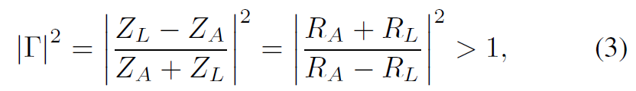reflection coefficient Ӷ becomes negative and greater than 1:

making the modulation factor *M* greater than one. Of course, the law of conversation of energy is preserved since the TR converts the applied dc bias into RF power.

Upon backscattering, the base-band signal received on an RFID reader is given by:

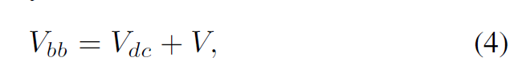

where Vbb is the base-band received signal, Vdc is the received dc component and V = V*I* + *j*V*Q* is the time-varying signal. The desired modulated-backscatter data can be extracted from the base-band signal by blocking Vdc with a series capacitor. Since environmental and reader noise affect the quality of the wireless link, V can be measured as the average of N bursts received over a period of time.

To measure the signal-to-noise ratio of the backscattering link, the modulation error ratio (*M E R*) can be used. It takes into account both the average of all the received symbols |V| and the average error magnitude |e|:

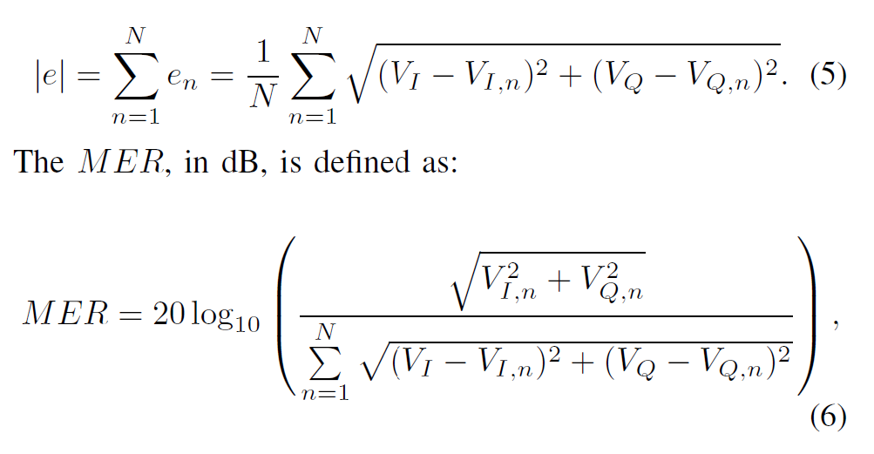

where V*I* and V*Q* are the in-phase and quadrature average components of the received, demodulated symbol; V*I,n* and V*Q,n* are the quadrature components of the received, demodulated n-th symbol; and *N* is the total number of the received symbols.

1. **The Experimental Setup**

(The data used in this section has been procured from the paper that is being referred to.)

The researchers of this paper have divided the experiment into four sections. The Microwave Reader, the Tunneling Tag, Instrument Calibration, and the Field Test Campaign. To test the backscattering capabilities of the prototype, a certain setup is used. It consists of a reader and a Tunneling Tag tuned at 5.8 GHz. The tag is placed at different distances r from the reader that collects and processes the backscattered data.

1. **The Microwave Reader**

Its transmitting section generates a 5.8 GHz CW of power PT and it is connected to an output antenna with gain Gtx. Its receiving section has a high-pass cut-off frequency of 20 kHz and a low-pass cutoff of 2 MHz. The LNA amplifies the received backscattered power Pr and a commercially available open-source universal software radio platform demodulates the data. The base-band data, Vbb, are filtered and sampled by an analog to digital converter and contain V*I,n* and V*Q,n* signals from the Tunneling Tag.

1. **The Tunneling Tag**

The 5.8 GHz Tunneling Tag consists of a TR connected to a tag antenna of gain Gt and a waveform generator that modulates, amplifies and backscatters the impinging CW through a biasing square wave of tunable voltage amplitude Vpp and frequency fm. The Tunneling Tag switches between two states at a constant rate; the square wave can be represented as a Fourier series whose fundamental frequency is fm, and has harmonics at integer multiples of this frequency.

1. **Instrument Calibration**

Since V = V*I* + *j*V*Q* corresponds to the average voltage measured at the I and Q output ports of the microwave reader, a calibration procedure was necessary to identify the offset correction G (in dB) that needs to be taken out for measuring the correct amount of power Pr at the receiving antenna terminals:

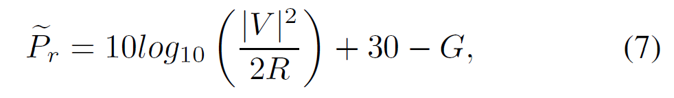

with *G* being the offset correction and *R* = 50 being the receiver impedance. Once the received power is both measured (*Pr*) through Eq. 7, and estimated (*Pr*) through the link budget equation3, the TR gains Ḡ *T R* can also be measured:

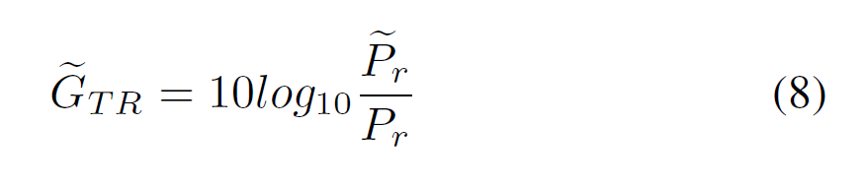

1. **The Field Test Campaign**

Tests were conducted by varying the distances *r* between the reader and the Tunneling Tag. For each distance, different bias voltages Vpp were applied for two or more modulation speeds fm.

One specific test used in the paper is as follows: Setup generates a CW with PT of only 0 dBm (1 mW) and an EIRP of 6 dBm (4 mW); it was used to test the tag backscattering capabilities for distances r between 25 m and 160 m. PT levels were measured by directly connecting the output of the reader to a spectrum analyzer; antenna gains were simulated and then verified through experimental tests; L1 and L2 define the losses of the cables connecting the transmitting and receiving antennas to the reader.

The data points obtained through the measurements campaign involving distance *r* between 25 m and 160 m were used to extrapolate a mathematical model that best describes the gains G*TR* for impinging powers ranging between -80 dBm and -55 dBm:

x being the power P*t*, in dBm, impinging on the TR.

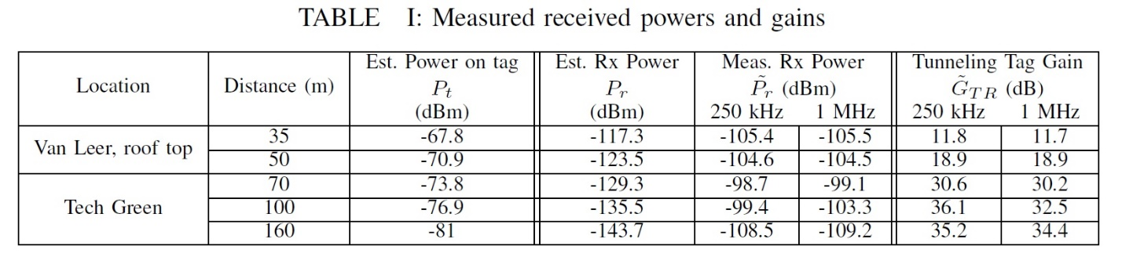The table above shows a part of the end results that the authors of the paper have procured through the field tests and measurement test campaign. It depicts for two of the chosen locations, Van Leer, roof top, and Tech Green, with the various distances used as a controlling agent in the experiment.

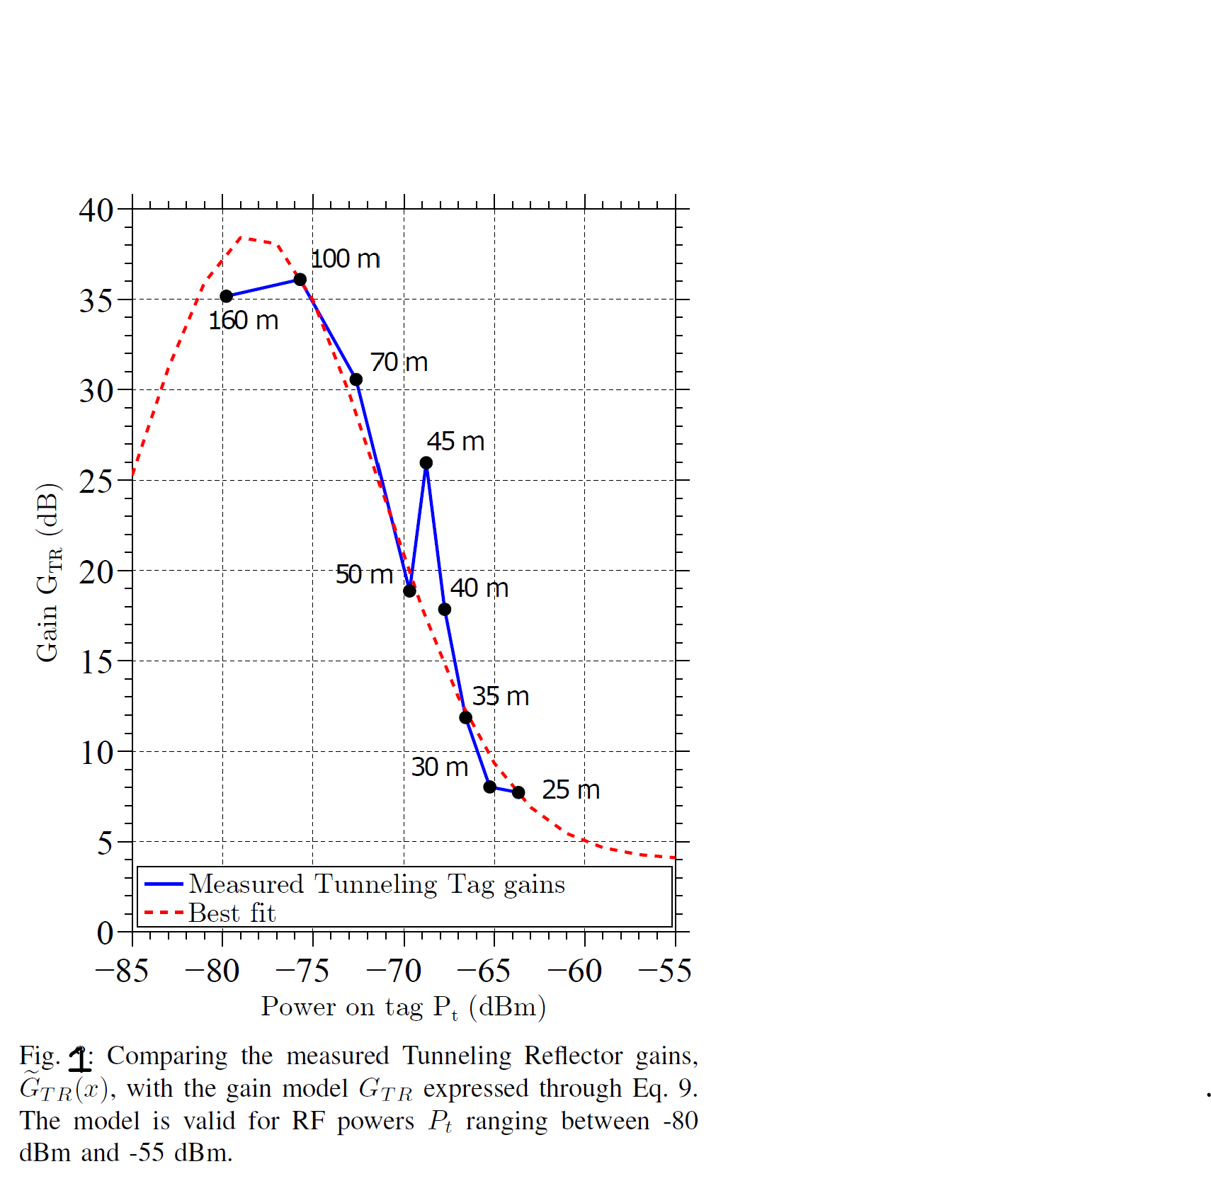

1. **Gain Model Validation and Modulation Errors**

(The data used in this section has been procured from the paper that is being referred to.)

To test the accuracy of the mathematical model (Eq. 9) in predicting the TR gains G*TR*, backscattering tests were held with the Tunneling Tag placed at 650 m and 1.2 km away from the reader. A summary of the results in shown in Table IV. The received powers Pr were measured from the reader and compared with the received powers P*r* (Eq. 2) extrapolated when using an ideal semi-passive tag (M = 1) in free-space. The gains G *TR* were retrieved through Eq. 8 and compared with the G*TR* computed through Eq. 9. The accuracy of the mathematical model in predicting the gains is evident; in fact, the TR gains both measured (Ḡ *TR*) and estimated (G*TR*) are the same at both 650 m and 1.2 km.

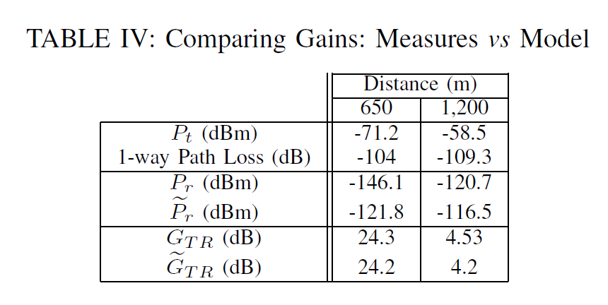Finally, the MER defined in Eq. 6 can be used to estimate the SNR ratio of the communication link between the reader and the Tunneling Tag.

1. **Considerations on Power Consumption**

The Tunneling Tag that was showcased here has a requirement of a certain biasing power to work in the manner it is supposed to. This requirement does not allow to identify the prototype as a passive transponder; nevertheless the consumed power is extremely low when compared to any other state-of-the-art RF wireless devices. Hence, a passive Tunneling Tag can be developed by adding a wireless energy harvesting module. This amount of biasing power, although very low, is enough to amplify very weak impinging RF signals whose amplitude is below -40 dBm. Moreover, since the modulation takes place by turning on and off the TR, only a fraction of this power is really used. Benefits for using a Tunneling Tag are also shared by the reader units. Thanks to the high sensitivity of the device, low impinging RF powers are enough to obtain backscattering modulation and amplification. The low powers required by the Tunneling Tag prototype contribute, from both an economically and environmentally point of view, to a future with billions of wireless devices.

1. **Conclusion**

The authors have constructed a system in which a reader, and a low powered Tunneling Tag which is capable of communicating at a very long range using backscattering communications at 5.8 GHz. With the help of this model, a tool was created to assist engineers to be able to construct future long distance backscattering systems. Using said tool, the future generation will be able to further advance in this field and will be able to create better solutions to existing problems as well be able to create more efficient solutions. The prototype that was created by the authors of this paper have developed it in such a way that it may be redesigned for the standard UHF frequencies at which even higher ranges may be reached.

By understanding the results, we can see that by reducing power requirements while granting considerable communication distances, and we can understand that the Tunneling Tag will help provide a bright future for wireless IoT devices and backscattering applications.

The larger scope that the authors have hoped for is that the tool they have developed should be used for the betterment of cities, schools and any other large distance design structures which all can benefit greatly from the use of several Tunneling Tags.

Tunneling Tags with the use of backscattering communication will allow for RFID tags in general as well as become more efficient towards energy consumption which in turn will allow for greater utilization and yield better results in the long run as well as for immediate use. Energy consumption and range are the two main drawbacks of any RFID system and hence this method could be one that solves the issue.

**References**

[1] Shao, Shuai, et al. “Broadband Textile-Based Passive UHF RFID Tag Antenna for Elastic Material.” *IEEE Antennas and Wireless Propagation Letters*, vol. 14, 2015.

[2] Scherhaufl, Martin, et al. “UHF RFID Localization Based on Evaluation of Backscattered Tag Signals.” *IEEE Transactions on Instrumentation and Measurement*, vol. 64, no. 11, 2015.

[3] Scherhaufl, Martin, et al. “Robust Localization of Passive UHF RFID Tag Arrays Based on Phase-Difference-of-Arrival Evaluation.” *2015 IEEE Topical Conference on Wireless Sensors and Sensor Networks (WiSNet)*, 2015.

[4] ATMEL. (Accessed Jan. 2018) Samb11. [Online]. Available: http: //www.atmel.com/Images/Atmel-42426-SmartConnect-SAMB11-SOC Datasheet.pdf

[5] Empire State Realty Trust, “Empire State building fact sheet,” Accessed Jan., 2018. [Online]. Available: http://www.esbnyc.com/sites/default/files/esb fact sheet 4 9 14 4.pdf

[6] C. He, Z. J. Wang, C. Miao, and V. C. M. Leung, “Block-level unitary query: Enabling orthogonal-like space-time code with query diversity for MIMO backscatter RFID,” IEEE Transactions on Wireless Communications, vol. 15, no. 3, pp. 1937–1949, March 2016.

[7] C. Boyer and S. Roy, “Invited paper - backscatter communication and RFID: Coding, energy, and MIMO analysis,” IEEE Transactions on Communications, vol. 62, no. 3, pp. 770–785, March 2014.

[8] S. Grebien, J. Kulmer, F. Galler, M. Goller, E. Leitinger, H. Arthaber, and K. Witrisal, “Range estimation and performance limits for UHF-RFID backscatter channels,” IEEE Journal of Radio Frequency Identification, vol. PP, no. 99, pp. 1–1, 2017.